Hands-On Assignment 4: Use Unsupervised Deep Learning Algorithm to Detect Fraud with PyOD

Sandip K C
Advance Artificial Intelligence
Dr. Ulrich Vouama
University of Cumberlands
Feb 21, 2026

Project Overview
This is a project of a fraud detention system founded on a deep learning-based AutoEncoder model in the PyOD library. I applied the anonymized credit card transactions data set on Kaggle to benchmark my model and train it. My primary goal was to identify fraudulent transactions through identification of abnormally behaving patterns of transactions. That the chances of occurrence of fraud cases are low as opposed to genuine transactions made me use anomaly detection methods in lieu of traditional classification methods.
Model Implementation
First of all, I preprocessed the dataset by dividing the features and the target variable and scaled the input data in order to maximize the performance of the neural networks. I then trained an AutoEncoder model, which is trained to re-construct normal transaction data, minimizing the reconstruction error. The model records the underlying structure of legitimate transactions in the course of training. In the case where the model is faced with fraudulent transactions, it will give a greater reconstruction error in that the patterns do not match the patterns that it has been trained on. According to this reconstruction error, the model distinguishes between normal and fraudulent transactions.
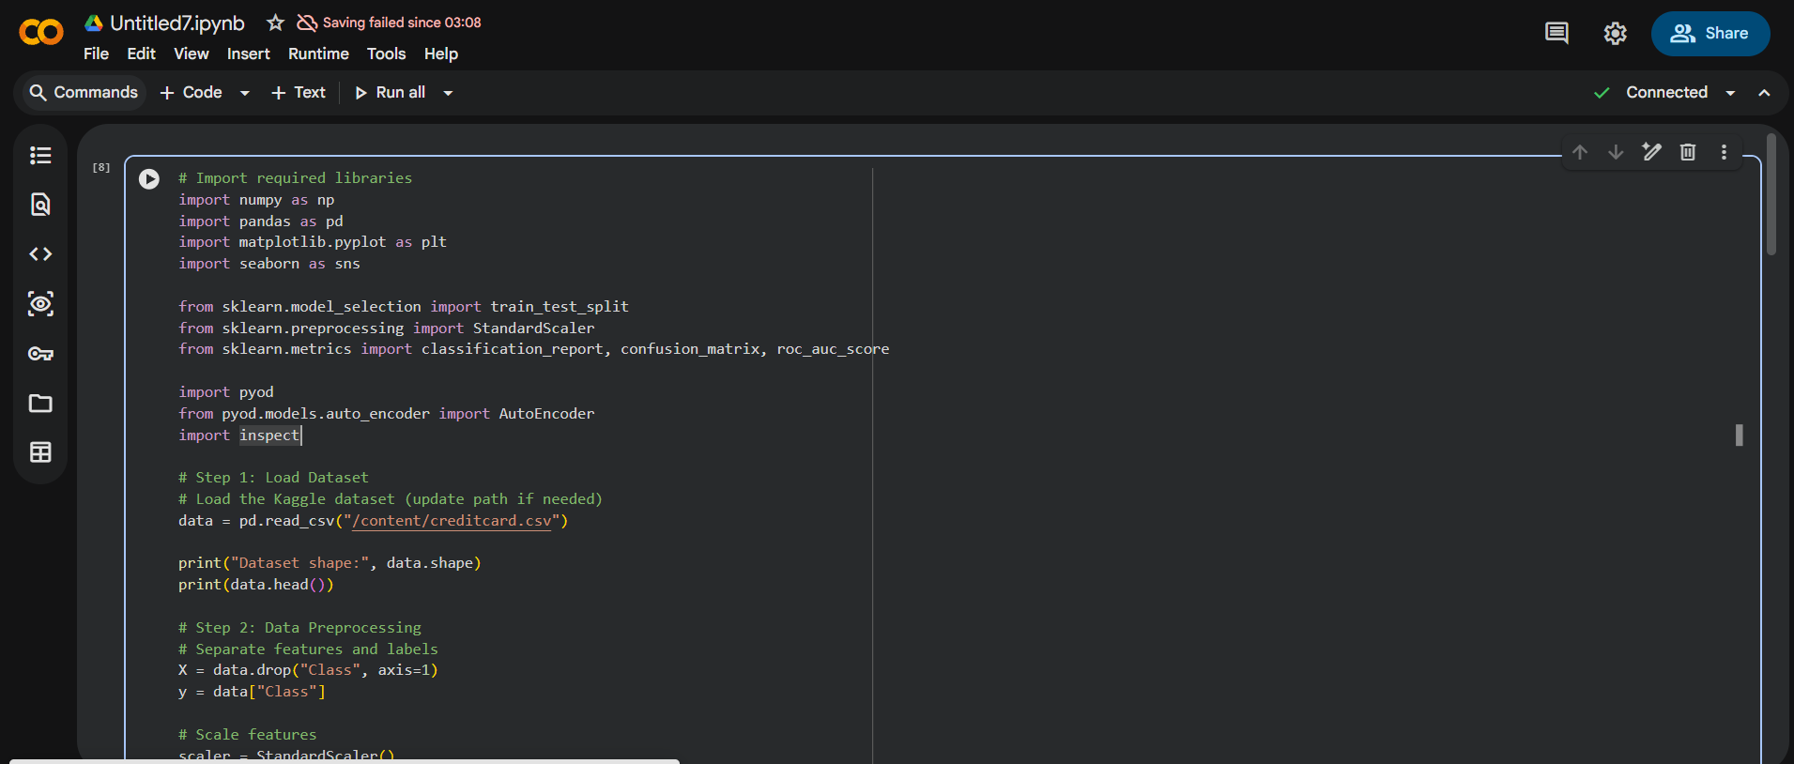
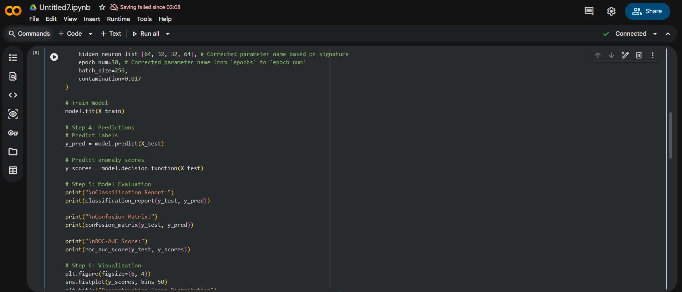
Model Evaluation and Results
I tested the model on performance measurements of precision, recall, F1-score, confusion matrix and ROC-AUC score. These measures have allowed me to know the effectiveness of the model in detecting fraud and minimizing false positives. The findings showed that the AutoEncoder was able to detect anomalous transactions by detecting an anomaly in regular patterns. In general, this experiment demonstrated that deep learning and anomaly detection algorithms can enhance the accuracy of fraud detection in a real-life financial system significantly.

